Live Q&A 2 Transcript
[I missed 2.11 because I had someone knocking on my door. Forgive me please!]

Preliminaries
- We will go through the stuff from the first week in your SGTs.
- We sincerely apologise for the timetabling. There is constant changes for in person teaching. You should allocated exactly 1 SGT session this week. Please contact the departmental office for timetabling.
Because of this, I have published a lot of links to the online SGT groups. It’s in the announcement this morning.
https://keats.kcl.ac.uk/mod/forum/discuss.php?d=296130
Please attend the session for your group. We don’t want large group tutorials!
- On the top of the FC1 KEATS page, there is a way to give feedback for the material covered. Please consider giving feedback via this link.

Questions from Week 2 Tutorial Exercises

2.3 Describe the set of all even positive natural numbers…
a) The first one is in the model solution. The other ones are equally good.
We don’t have to be formal. We just have to use the same pointers in between the pipe.
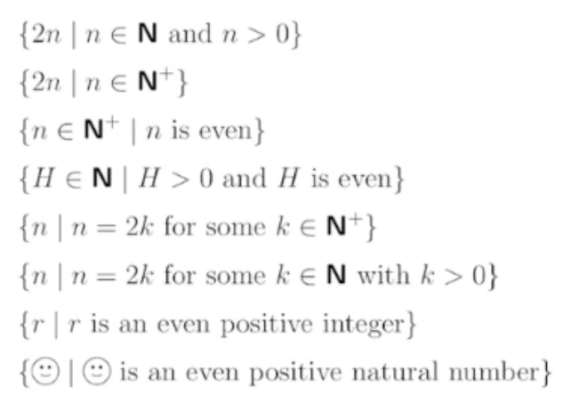

b) The basis step and the recursive step is important. We specify one or more elements and a way to achieve other elements.
Everything that should be in the set is in.
Everything that should be out of the set is out.
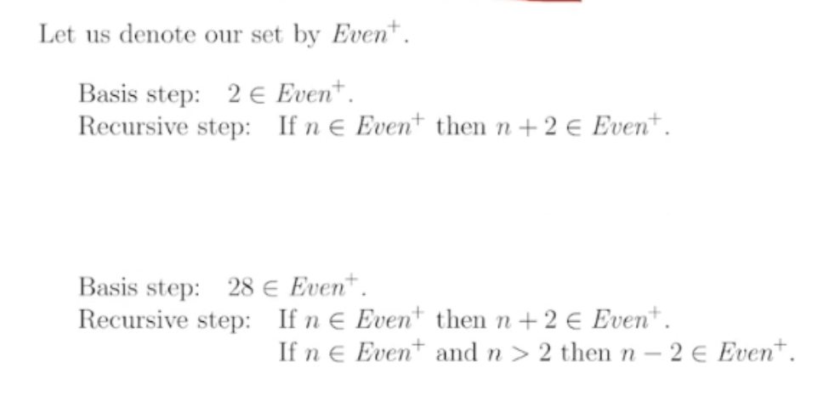

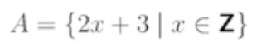
2.4 Describe the set by recursion:
You’ll realise that this is just the set for all odd integers.
Basis step: give x any value.
Recursive step: add 2 or subtract 2 to get other values.


2.6 Show that if A and B are any sets, then this holds:
We need a general direct proof. An example, like a Venn diagram, is not enough. is not enough

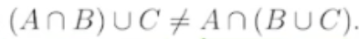
2.7 Show that there are sets A, B, C such that:
Here, it is enough to give an example.
[I redrew Agi’s diagram for the benefit of your eyes]
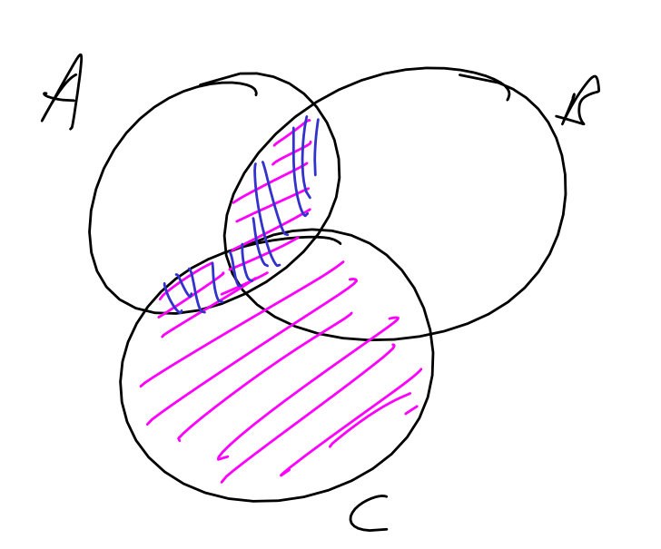

2.9 For each of the following relations on the set {1,2,3,4}…
a) It is useful to draw the relational diagram for each graph.
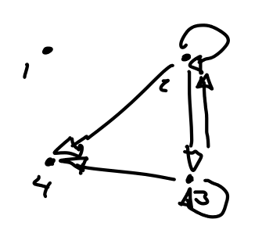
- Transitive: “every 2 step journey can be done in 1 step”
  - This is true.
- Reflexive: “every point loops”
Irreflexive: “no point loops”
  - These are both false
- Symmetric: “All arrows come in pairs”
Antisymmetric: “No arrow pairs come in both ways unless in loops”
  - These are both false.

2.10 Take the relation…
a)
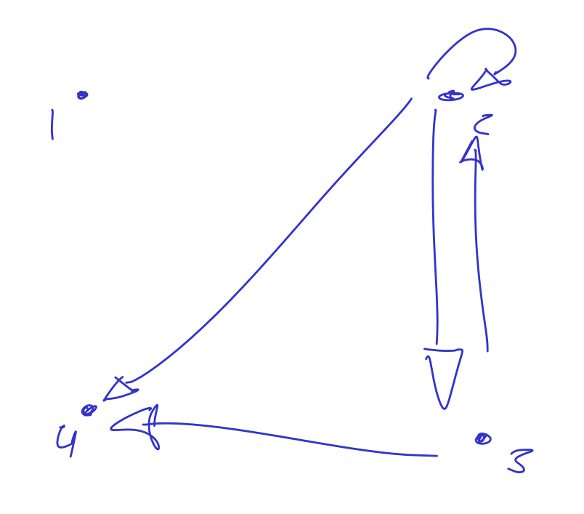

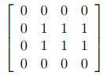
b) (2,2), (2,3), (2,4) are in the relation. So…

2.11 Consider the following matrix…
Yes, it represents the relation in 2.9(b)
Why?
- Count the 1s. There are 6 1s
- Count the diagonal 1s. There must be 4 looping pairs.

Questions and Answers

Where are the solutions?
You can find them on KEATS. I usually announce them.

Can you replace the smiley face with the triangle?
You can!

Why are the SGTs only week 1 material?
Just for this week it will cover one week. I find it useful to mix the various material from other weeks to jog your memory.

Should we do the material before?
Optimally, you shold

Why is there SGTs every other week?
We don’t have enough staff for every week.

